

**Summer and Sports Camp 2024!**

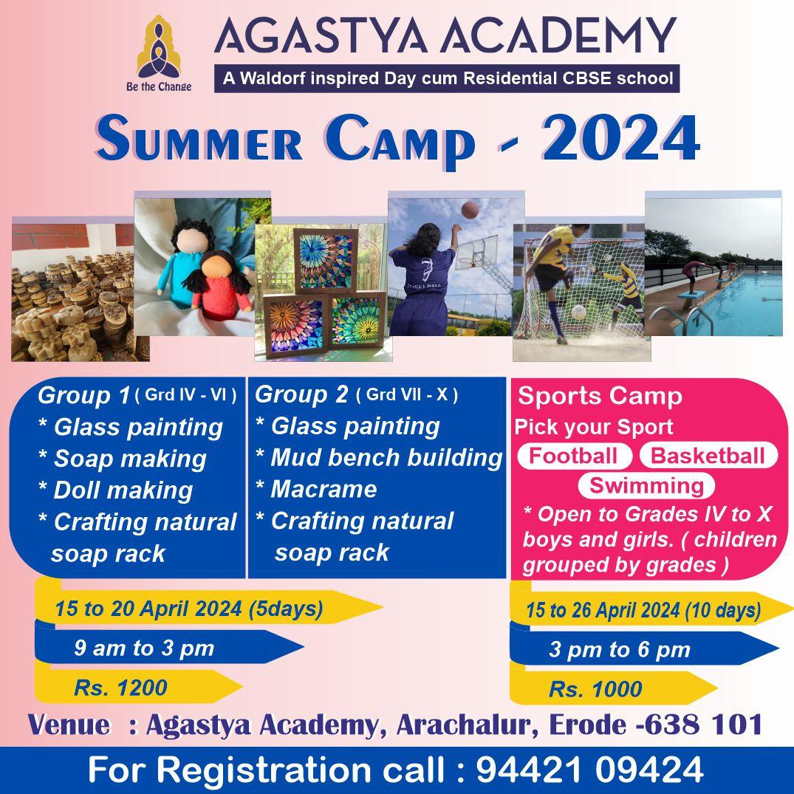

Join us at Agastya Academy for an enriching Summer Camp and Sports Camp experience to enjoy your holidays! We aim to offer a range of activities catered to different age groups. From glass painting to soap making, doll making to macrame, there's something for everyone to explore and create. For sports enthusiasts, our Sports Camp offers the opportunity to pick your favorite sport - football, basketball, or swimming - and hone your skills under expert guidance. Open to boys and girls from Grades IV to X, our camps promise 5 to 10 days of fun-filled learning and adventure from 15th to 26th April 2024. Don't miss out on this exciting opportunity to learn and play from April 15th to 26th. Register now by calling 94421 09424!